
BAI22123 Object Oriented Programming
SEPT YEAR 2026
Project Proposal

By
Chow Kai Jie BAI_A2009F-2509001

Course Code:
Lecturer: Mr. Ng Choon Ching
Raffles University

Table of Contents
1.0 Introduction 1
2.0 Problem Statement 2
3.0 Objective 3
4.0 System Requirements 4
5.0 System Design 5
6.0 Object-oriented Programming Solutions 6
7.0 Proposed System Features 7
8.0 Target User 10
9.0 Proposed Classes 11
10.0 Entity Relationship Diagram 21
11.0 Use Case Diagram 22
12.0 System Architecture Diagram 18
13.0 Bonus Mark Alignment 24
14.0 References 25

1.0 Introduction
This project is going to develop a car rental software application by applying the C++ Programming and Object-Oriented Programming (OOP) concepts learned. The frontend interface will be developed using HTML, CSS, and JavaScript to provide an intuitive Graphical User Interface (GUI) for end-users and administrators. The objective of this project is to develop a functional Car Rental Management System using C++ that applies fundamental programming concepts and object-oriented programming principles. The system will demonstrate the use of classes, objects, encapsulation, abstraction, inheritance, and polymorphism, while applying appropriate data structures and algorithms to manage cars, customers, bookings, and rental fees. This project also aims to provide practical experience in developing, testing, and debugging a functional C++ application.

2.0 Problem Statement
2.1 Disputes and Damages
Nowadays, vehicle damage disputes are common in car rental businesses, causing frustration for both rental companies and customers. Traditional car rental businesses often rely on manual tracking of vehicle conditions, inspection records, and repair costs, which can lead to billing disputes. Without a clear and transparent process, these disputes can reduce customer trust and damage the company’s reputation.
2.2 Manual Booking Systems & Long Customer Wait Times
A common problem for vehicle rental businesses is the inefficiency of manual booking systems. These outdated processes can cause double bookings, incorrect availability information, and poor customer service. They can also slow down the check-in and check-out processes, leading to long queues. During peak hours, manual booking errors and long waiting times are common customer complaints.
2.3 Fixed Pricing Models Affecting Profits and Customer Attraction
Applying similar fixed rental prices across different vehicle categories does not consider differences in vehicle value, maintenance costs, and operating expenses. This may lead to unfair profit distribution among vehicle owners. Fixed rental prices without discounts for longer rental periods may discourage customers from renting vehicles for extended durations, reducing rental opportunities and overall business revenue.
2.4 Lack of Fleet Visibility and Status Tracking
Rental managers often lack visibility of vehicle status, condition, and availability. Traditional fleet management methods can lead to wasted time, inefficiency, and potential misuse of vehicles. They also make administrative tasks more difficult, such as tracking active rentals and customer return dates.

3.0 Objective
The primary objective of this project is to design, develop, and deploy a fully functional, web-enabled Car Rental Management System using C++ as the backend engine and an intuitive HTML/CSS/JavaScript graphical user interface.
To achieve project requirements, the system's objectives are categorized into system-level functional goals and technical object-oriented goals.
1. Functional & Business Objectives
- Automate Fleet and Inventory Management: Provide real-time tracking of vehicle availability, status (Available, Rented, Under Maintenance), mileage, and service histories through an administrative dashboard.
- Streamline Reservation and Booking Workflows: Implement efficient vehicle lookup using std::unordered_map, SQL date-range overlap validation to prevent double-bookings, and automatic reservation status updates triggered when the application or relevant API routes are accessed.
- Implement Dynamic and Flexible Pricing: Replace rigid pricing models with polymorphic rental fee calculations that automatically adjust based on vehicle tiers (Standard, Luxury, SUV), security deposits, insurance rates, and long-term rental discounts for specific vehicle types.
- Resolve Vehicle Inspection: Establish a transparent digital damage-assessment workflow utilizing component checklists, and polymorphic damage fee calculations for user to pay for it.
- Ensure Reliable Data Persistence: Integrate a SQLite database to persistently store and recover customer accounts, vehicle inventories, reservation histories, damage logs, and maintenance records across application restarts.
2. Technical & Object-Oriented Programming Objectives
- Demonstrate Core OOP Principles: Effectively apply encapsulation (data hiding and controlled state-transition methods), inheritance (multi-tier vehicle and fee hierarchies), abstraction (pure virtual interfaces), and polymorphism (runtime dynamic dispatch for fees).
- Leverage Advanced C++ Features: Utilize modern memory management principles (std::unique_ptr), STL data structures (std::unordered_map), exception handling, and move semantics to ensure high performance and code safety.
- Build a Decoupled System Architecture: Successfully bridge a high-performance C++ web backend (powered by the Crow framework) with a clean, responsive frontend web interface.

4.0 System Requirements
Software Requirements
- Operating System: Windows or Linux or a terminal/command prompt for building and running the application
- Development Tools: C++ compiler supporting at least C++14 features, including std::unique_ptr, std::make_unique, std::unordered_map and move semantics
- Required C++ Libraries:
  - Crow v1.2.0 — HTTP web server and REST API
  - Asio 1.30.2 — asynchronous networking support
  - SQLiteCpp v3.3.1 — C++ wrapper for SQLite
  - SQLite is bundled through SQLiteCpp, so a separate SQLite installation is generally unnecessary
- Database Requirements:
  - A writable SQLite database file named car_rental.db
  - The application automatically creates and upgrades the required tables (refer the ER Diagram)
- Functional Software Requirements:
  - Customer registration and login
  - Administrator login
  - Vehicle creation, editing, deletion, filtering, and maintenance management
  - Vehicle reservations with date validation
  - Duplicate and overlapping booking prevention
  - Automatic reservation check-in and overdue detection
  - Tier-based rental pricing
  - Vehicle checkout and return inspection
  - Component-based damage assessment
  - Polymorphic damage-fee calculations
  - Customer damage-fee payment
  - Reservation and maintenance history
  - Persistent data storage through SQLite

5.0 System Design
This Car Rental System is engineered using a decoupled client-server architecture. The system separates the presentation layer (HTML/CSS/JavaScript graphical user interface) from the core business logic and data persistence layers, which are built entirely in C++ using object-oriented principles and an embedded SQLite database.
1. Architectural Overview & Component Interaction
The system relies on a RESTful API web server pattern powered by the Crow C++ microframework:
- Presentation Layer (Client): Renders dynamic web pages, handles user input (e.g., login credentials, vehicle bookings, damage inspection checklists, and mileage submissions), and communicates asynchronously with the backend via HTTP GET and POST requests.
- Control & Routing Layer (Server): main.cpp initializes the database connection, registers authentication providers, and defines REST API endpoints (e.g., /api/login, /api/vehicles, /api/reservations) that handle incoming traffic using lambda expressions.
- Domain & Business Logic Layer: Encapsulates core workflows inside dedicated classes like RentalSystem, Reservation, and polymorphic inheritance trees (Vehicle, DamageFeeCalculator, OverdueFeeCalculator, and AuthenticationProvider).
- Data Access Layer: Manages relational persistence by executing SQL queries against an embedded SQLite database, ensuring all changes to inventory, users, and transactions are securely saved.
2. Object-Oriented Design & Class Relationships
The system utilizes robust object-oriented relationships to promote modularity, maintainability, and code reuse:
- Inheritance ("Is-A"):
  - The Vehicle abstract base class defines pure virtual functions (category() and calculateRentalFee()), which are specialized by derived subclasses (StandardCar, LuxuryCar, and SUV).
  - Similar polymorphic hierarchies are established for fee processors (DamageFeeCalculator and OverdueFeeCalculator) and authentication providers (CustomerAuthenticationProvider and AdministratorAuthenticationProvider).
- Composition & Aggregation ("Has-A"):
  - The central RentalSystem class manages vehicle inventory using an STL hash map (std::unordered_map<std::string, std::unique_ptr<Vehicle>>), demonstrating strict ownership and memory management via smart pointers.
  - Reservation objects aggregate customer and vehicle identifiers alongside booking dates and fee calculations to maintain transaction integrity.

6.0 Object-oriented Programming Solutions
6.1 Solution for Disputes and Damages
Creating a base class Vehicle and derived class such as StandardCar, LuxuryCar, and SUV. Then, implementing an abstract function calculateDamageFee (double severityScore) using polymorphism. For instance, repairing a scratched LuxuryCar computes a higher rate or multiplier than a StandardCar. Storing inspection logs inside a std::vector<string> or a custom DamageLog object ensures its transparent record-keeping. Besides, system can automatically generate damage reports that are easy to review and allowing customers to review them and pay for the damage fee.
6.2 Solution for Manual Booking Systems & Long Customer Wait Times
Implement a centralized RentalSystem class that manages fleet availability in real time. Use STL containers like std::unordered_map<string, Vehicle*> for O(1) fast lookup by License Plate or Vehicle ID or std::vector combined with std::find_if algorithm. Automated availability state changes (Available Rented) execute instantly, preventing double-bookings and speeding up transactions. System also offers date/duration validation utilities and automatic booking schedules stored in system memory. Automated transaction processing within the terminal is necessary to avoid long waiting time and improve efficiency of rental process.
6.3 Solution for Fixed Pricing Models Affecting Profits and Customer Attraction
Define an abstract method virtual double calculateRentalFee(int days) const = 0 inside the base Vehicle class. Each derived vehicle class overrides this method to calculate rental fees based on its vehicle category, considering differences in vehicle value and operating costs. Additionally, apply automatic percentage discounts for long-term rentals (e.g., 15% discount for rentals of 7 days or more). This ensures fairer pricing for vehicle owners while encouraging customers to rent vehicles for longer periods and increasing overall rental opportunities.

6.4 Solution for Lack of Fleet Visibility and Status Tracking
Implement an automated fleet management system that updates vehicle availability and rental status based on rental dates, preventing double bookings. When a customer returns a vehicle, an administrator performs a physical inspection, checks vehicle components, and submits a damage report if necessary. Customers must settle any applicable damage fees before completing the return process. Additionally, the system automatically detects overdue returns and calculates additional fees for late vehicle returns.

7.0 Proposed System Features
Currently, our proposed system features mainly focus on five modules, which is vehicle and fleet management module, reservation and booking management module, dynamic pricing and revenue management module, vehicle inspection and dispute management module and data persistence and file I/O module.
7.1 Vehicle & Fleet Management Module
- Multi-Tier Vehicle Hierarchy: Supports different vehicle types such as Standard Car, Luxury Car, and SUV using a common base class.
- Fleet Status Tracking: Tracks vehicle status, mileage, and assigned customers in real time.
- Maintenance Tracking: Records vehicle service history and maintenance logs.
- Role-Based Access: Provides full access for administrators and limited access for customers.
7.2 Reservation and Booking Management Module
- Instant Availability and Fast Lookup: Real-time vehicle availability management powered by STL containers (std::unordered_map / std::vector with std::find_if) using License Plate or Vehicle ID.
- Automated Check-in & Overdue Detection: Automatically check-in vehicle based on the Today date and booking date. Overdue detection and overdue fee calculation for late vehicle returns.
- Date & Duration Validation: Checks rental dates and duration to ensure valid bookings and prevent overlap bookings.
7.3 Dynamic Pricing & Revenue Management Module
- Polymorphic Rental Fee: Calculates rental fees differently for each vehicle type.
- Tier-Specific Fees: Adds security deposits, luxury charges, and insurance fees for higher-tier vehicles.
- Long-Term Discounts: Automatically applies discounts for long-term rentals.
7.4 Vehicle Inspection & Dispute Management Module
- Polymorphic Damage Fee: Calculates damage fees based on damage component and vehicle type when user return a vehicle.
- Damage Inspection Logs: Records detailed damage inspection history.
- Customer Verification: Allows customers to confirm and verify damage details before billing.
7.5 Data Persistence & File I/O Module
- Automatic Data Storage & Recovery: Saves and loads vehicle, customer, and transaction data using SQLite Database.
- Persistent Service & Damage Records: Keeps damage and maintenance records after the system restarts.

Except from this five modules, the system also allow customer to create new account and login with the valid username and password. Besides, admin also can add new vehicle to the system, so the customer can rent it.

8.0 Target User
This Car Rental System is designed to serve two main user groups, which is rental customers and rental agency administrators. The first target group consists of individual and corporate customers who need an efficient platform to select, book, and manage vehicle rentals. Through a dedicated customer menu interface, these users can register new accounts, log in securely, browse available vehicle models across standard, luxury, and SUV categories, and check their selected rental dates. Customers can also view digital details of the reservation after checkout and confirm any existing or post-rental vehicle damage through customer sign-off verification.

The second target group consists of rental agency staff and system administrators who are responsible for managing daily fleet operations and rental activities. Through an administrative interface, they have access to fleet management functions, including searching for vehicles, updating vehicle status such as available, rented, or under maintenance, and managing rental transactions. Administrators can also use automatic calculation functions to calculate daily rental costs and damage fees, maintain vehicle inspection records, manage customer sign-offs, and keep system records by saving and loading data from files.

9.0 Proposed Classes
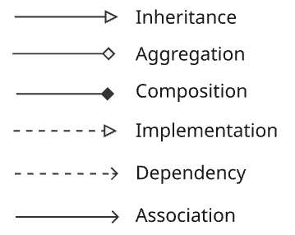
Inheritance: Represents an "is-a" relationship between a parent class (superclass) and a child class (subclass). The child inherits attributes and methods from the parent.
Aggregation: Represents a "has-a" relationship (weak whole-part relationship). The child/part can exist independently of the parent/whole (e.g., a Department has Professors, but if the department closes, the professors still exist).
Composition: Represents a strict "part-of" relationship (strong whole-part relationship). The part cannot exist without the whole; if the parent is destroyed, its parts are destroyed with it (e.g., a House has Rooms).
Implementation: Used when one class implements the behavior or contract specified by an interface (e.g., a Dog class implements an Animal interface).
Dependency: Represents a "uses-a" relationship. A change in one class (the independent one) may affect the other class (the dependent one) because it uses it temporarily (e.g., as a method parameter or local variable).
Association: Represents a general structural connection or reference between two independent classes (e.g., a Student is enrolled in a Course).
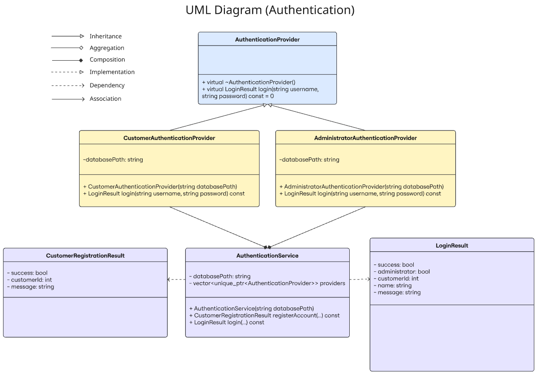
Figure 1 UML Diagram - Authentication
Table 1 Authentication Class
Class | Function Signature | Access | Primary Action / Purpose
AuthenticationProvider | virtual ~AuthenticationProvider() | public | Virtual destructor for derived authentication providers.
AuthenticationProvider | virtual LoginResult login(const string&, const string&) const = 0 | public | Abstract login interface.
CustomerAuthenticationProvider | CustomerAuthenticationProvider(const string& databasePath) | public | Initializes customer authentication with database path.
CustomerAuthenticationProvider | LoginResult login(const string&, const string&) const | public | Authenticates a customer account.
AdministratorAuthenticationProvider | AdministratorAuthenticationProvider(const string& databasePath) | public | Initializes administrator authentication.
AdministratorAuthenticationProvider | LoginResult login(const string&, const string&) const | public | Authenticates an administrator account.
AuthenticationService | AuthenticationService(const string& databasePath) | public | Creates and manages authentication providers.
AuthenticationService | CustomerRegistrationResult registerAccount(...) const | public | Registers a new customer account.
AuthenticationService | LoginResult login(...) const | public | Attempts login through available providers.

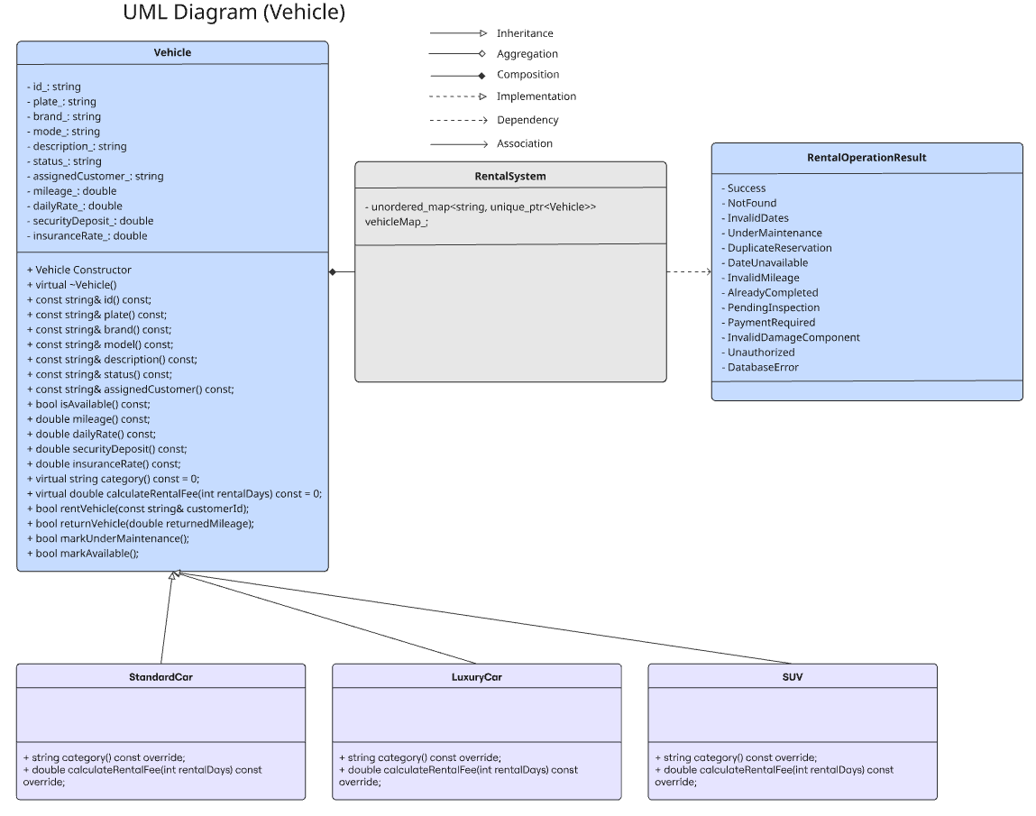
Figure 2 UML Diagram - Vehicle
Table 2 Vehicle Class
Class | Function Signature | Access | Primary Action / Purpose
Vehicle | Vehicle(...) | public | Initializes vehicle information.
Vehicle | virtual ~Vehicle() | public | Safely destroys derived vehicle objects.
Vehicle | const string& id() const | public | Returns vehicle ID.
Vehicle | const string& plate() const | public | Returns license plate.
Vehicle | const string& brand() const | public | Returns vehicle brand.
Vehicle | const string& model() const | public | Returns vehicle model.
Vehicle | const string& description() const | public | Returns vehicle description.
Vehicle | const string& status() const | public | Returns current vehicle status.
Vehicle | const string& assignedCustomer() const | public | Returns assigned customer ID.
Vehicle | bool isAvailable() const | public | Checks whether the vehicle is available.
Vehicle | double mileage() const | public | Returns current mileage.
Vehicle | double dailyRate() const | public | Returns daily rental rate.
Vehicle | double securityDeposit() const | public | Returns security deposit.
Vehicle | double insuranceRate() const | public | Returns insurance rate.
Vehicle | virtual string category() const = 0 | public | Returns the vehicle category.
Vehicle | virtual double calculateRentalFee(int) const = 0 | public | Calculates category-specific rental fee.
Vehicle | bool rentVehicle(...) | public | Rents the vehicle to a customer.
Vehicle | bool returnVehicle(...) | public | Returns the vehicle and updates mileage/status.
Vehicle | bool markUnderMaintenance(...) | public | Marks a vehicle as under maintenance.
Vehicle | bool markAvailable(...) | public | Marks a vehicle as available after maintenance.
StandardCar | string category() const | public | Returns StandardCar.
StandardCar | double calculateRentalFee(int) const | public | Calculates standard-car rental fee.
LuxuryCar | string category() const | public | Returns LuxuryCar.
LuxuryCar | double calculateRentalFee(int) const | public | Calculates luxury-car rental fee.
SUV | string category() const | public | Returns SUV.
SUV | double calculateRentalFee(int) const | public | Calculates SUV rental fee.
RentalSystem | void addVehicle(unique_ptr<Vehicle>) | public | Adds a vehicle to the vehicle collection.
RentalSystem | void removeVehicle(const string&) | public | Removes a vehicle by ID.
RentalSystem | Vehicle* findVehicle(const string&) | public | Finds a vehicle by ID.
RentalSystem | RentalOperationResult createReservation(...) | public | Validates and creates a reservation.
RentalSystem | RentalOperationResult checkoutVehicle(...) | public | Processes vehicle checkout and overdue fee calculation.
RentalSystem | bool rentVehicle(...) | public | Rents a vehicle.
RentalSystem | bool returnVehicle(...) | public | Returns a vehicle and updates the database.

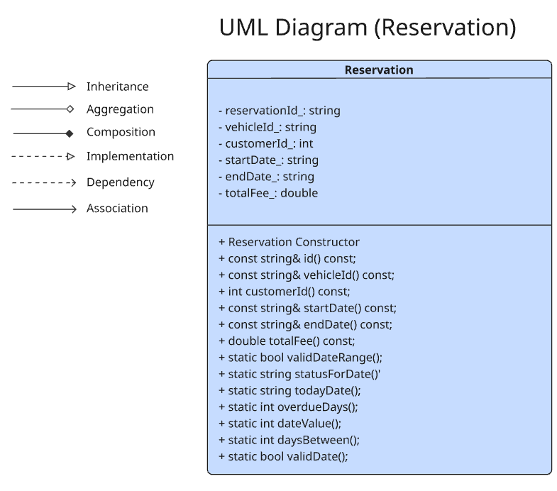
Figure 3 UML Diagram - Reservation
Table 3 Reservation Class
Class | Function Signature | Access | Primary Action / Purpose
Reservation | Reservation() | public | Creates an empty reservation.
Reservation | Reservation(...) | public | Creates a reservation and calculates rental fee.
Reservation | const string& id() const | public | Returns reservation ID.
Reservation | const string& vehicleId() const | public | Returns reserved vehicle ID.
Reservation | int customerId() const | public | Returns customer ID.
Reservation | const string& startDate() const | public | Returns rental start date.
Reservation | const string& endDate() const | public | Returns rental end date.
Reservation | double totalFee() const | public | Returns total rental fee.
Reservation | static bool validDateRange(...) | public | Validates reservation dates.
Reservation | static string statusForDate(...) | public | Determines confirmed, active, or overdue status.
Reservation | static string todayDate() | public | Returns the current date.
Reservation | static int overdueDays(...) | public | Calculates the number of overdue days.
Reservation | static int dateValue(...) | private | Converts a date into a comparable integer.
Reservation | static int daysBetween(...) | private | Calculates the number of days between two dates.
Reservation | static bool validDate(...) | private | Validates date format and values.

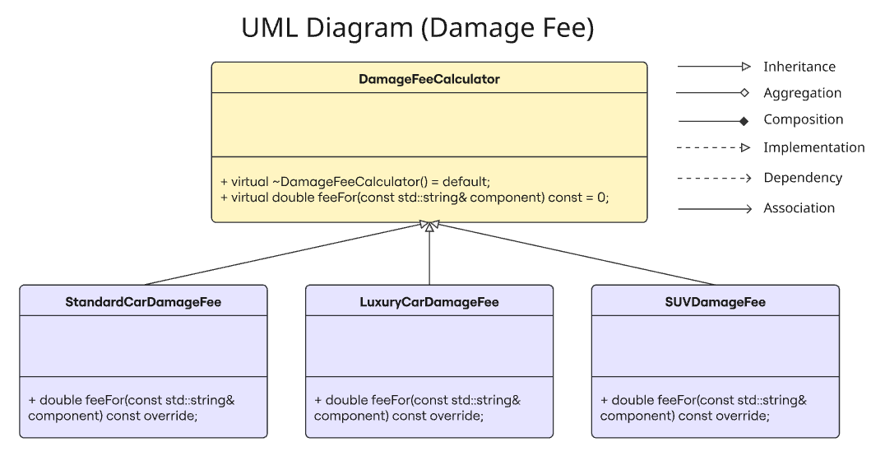
Figure 4 UML Diagram - Damage Fee
Table 4 - Damage Fee Class
Class | Function Signature | Access | Primary Action / Purpose
DamageFeeCalculator | virtual ~DamageFeeCalculator() | public | Virtual destructor for damage calculators.
DamageFeeCalculator | virtual double feeFor(const string&) const = 0 | public | Abstract damage-fee calculation interface.
StandardCarDamageFee | double feeFor(const string&) const | public | Calculates standard-car damage fee.
LuxuryCarDamageFee | double feeFor(const string&) const | public | Calculates luxury-car damage fee.
SUVDamageFee | double feeFor(const string&) const | public | Calculates SUV damage fee.
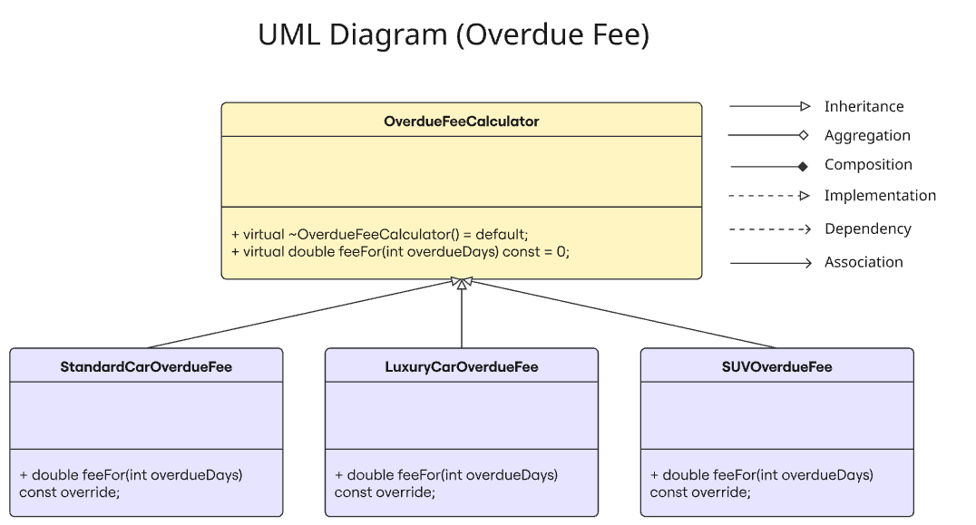
Figure 5 UML Diagram - Overdue Fee
Table 5 Overdue Fee Class
Class | Function Signature | Access | Primary Action / Purpose
OverdueFeeCalculator | virtual ~OverdueFeeCalculator() | public | Virtual destructor for overdue-fee calculators.
OverdueFeeCalculator | virtual double feeFor(int overdueDays) const = 0 | public | Abstract overdue-fee calculation interface.
StandardCarOverdueFee | double feeFor(int overdueDays) const | public | Calculates standard-car overdue fee.
LuxuryCarOverdueFee | double feeFor(int overdueDays) const | public | Calculates luxury-car overdue fee.
SUVOverdueFee | double feeFor(int overdueDays) const | public | Calculates SUV overdue fee.

10.0 Entity Relationship Diagram
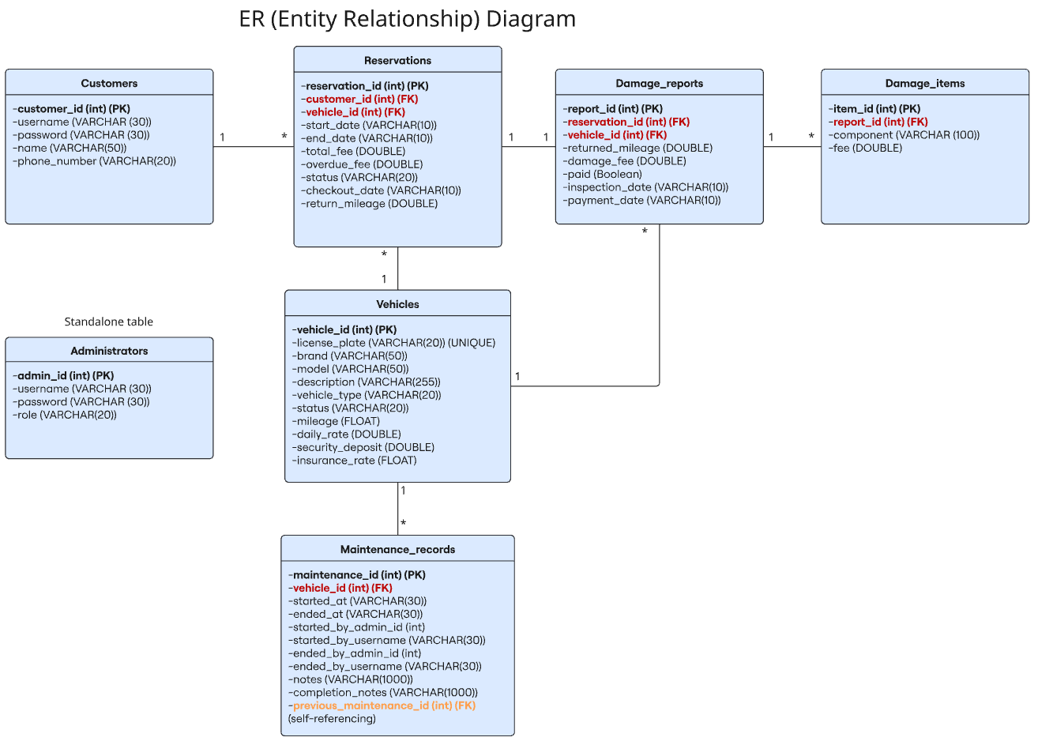
Figure 6 ER Diagram

11.0 Use Case Diagram
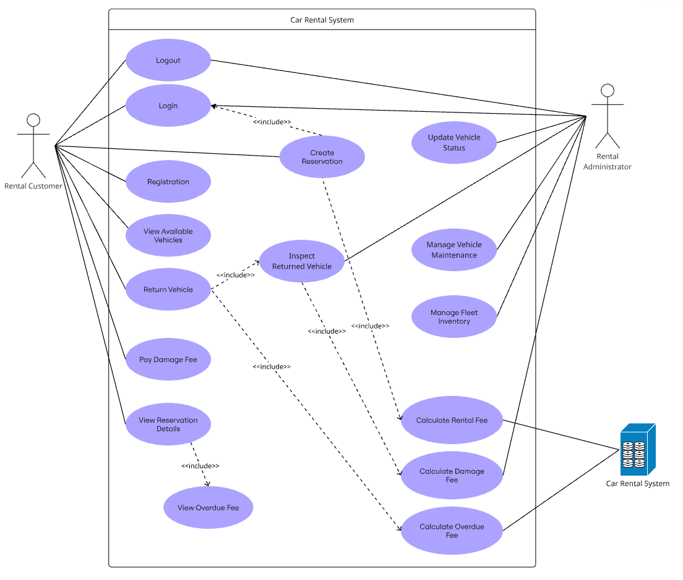
Figure 7 Use Case Diagram

12.0 System Architecture Diagram
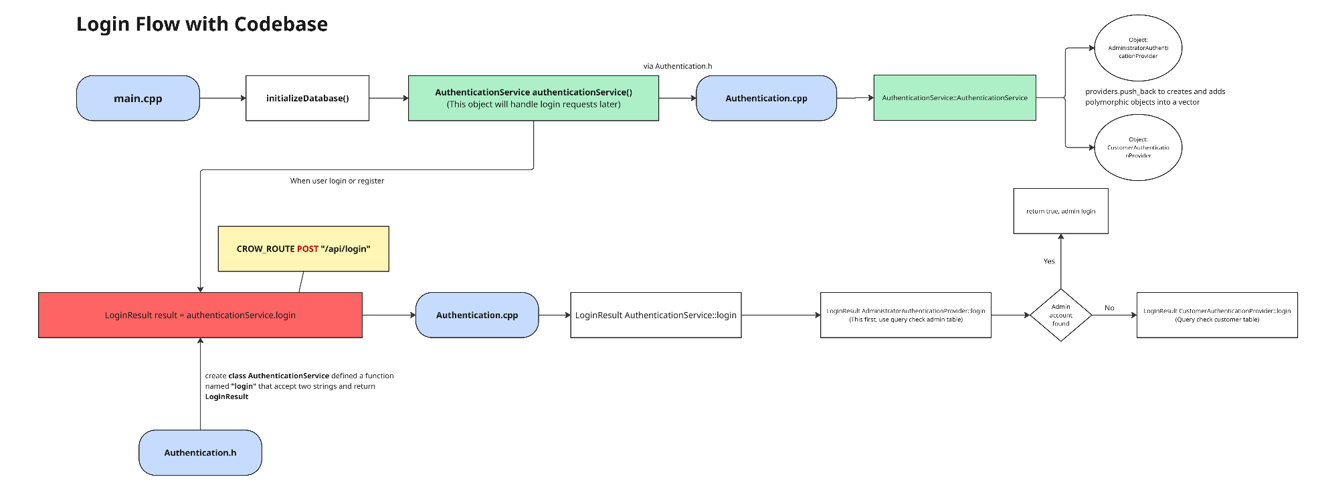
Figure 8 System Architecture - Login
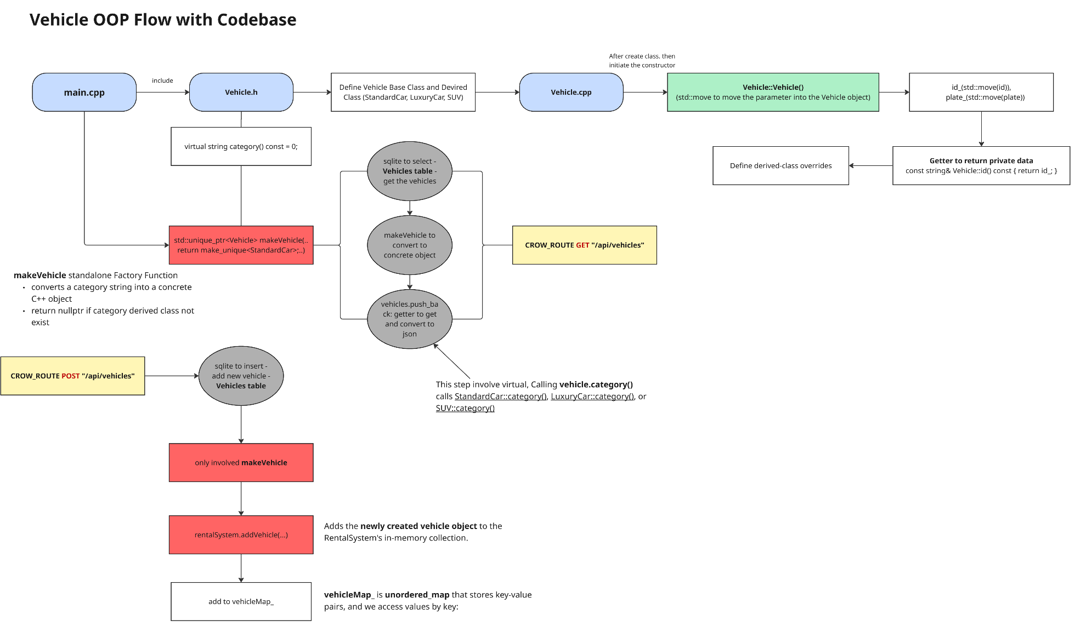
Figure 9 System Architecture - Vehicle
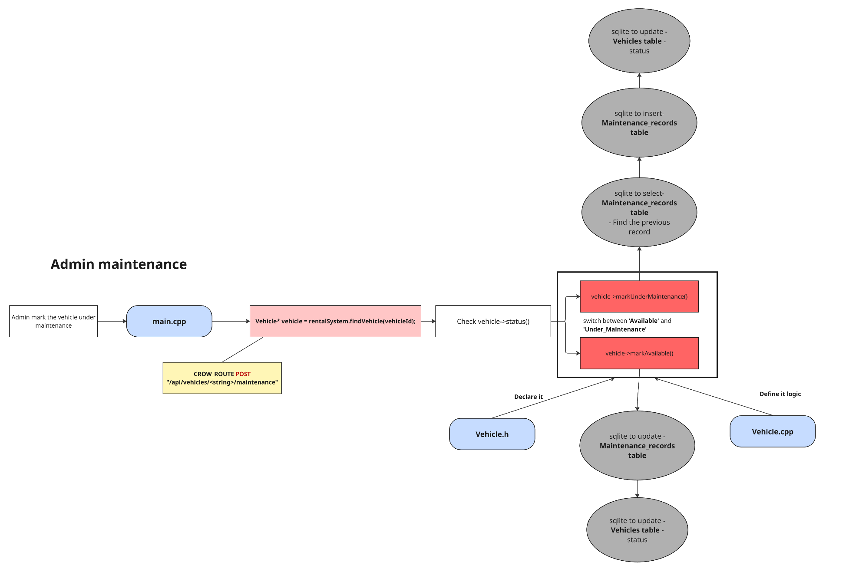
Figure 10 System Architecture - Admin Maintenance
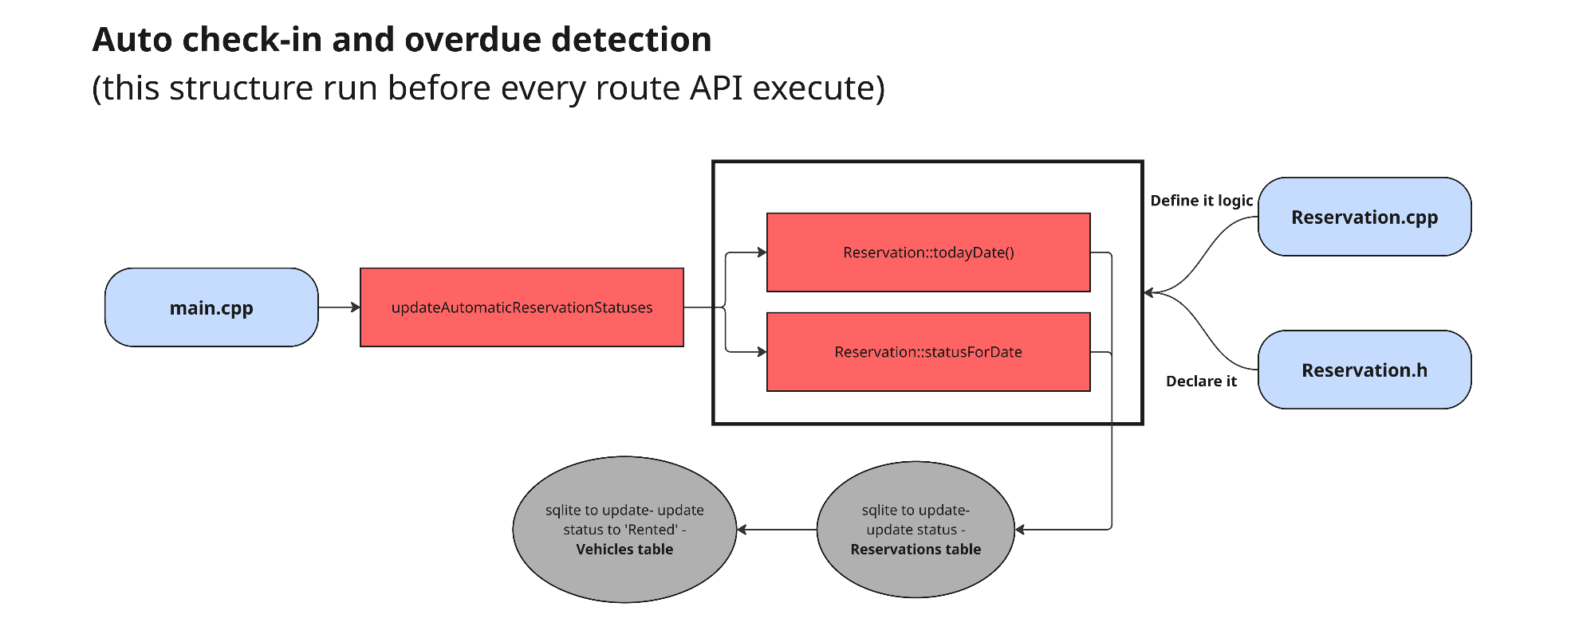
Figure 11 System Architecture - Auto Check-in and Overdue Detection
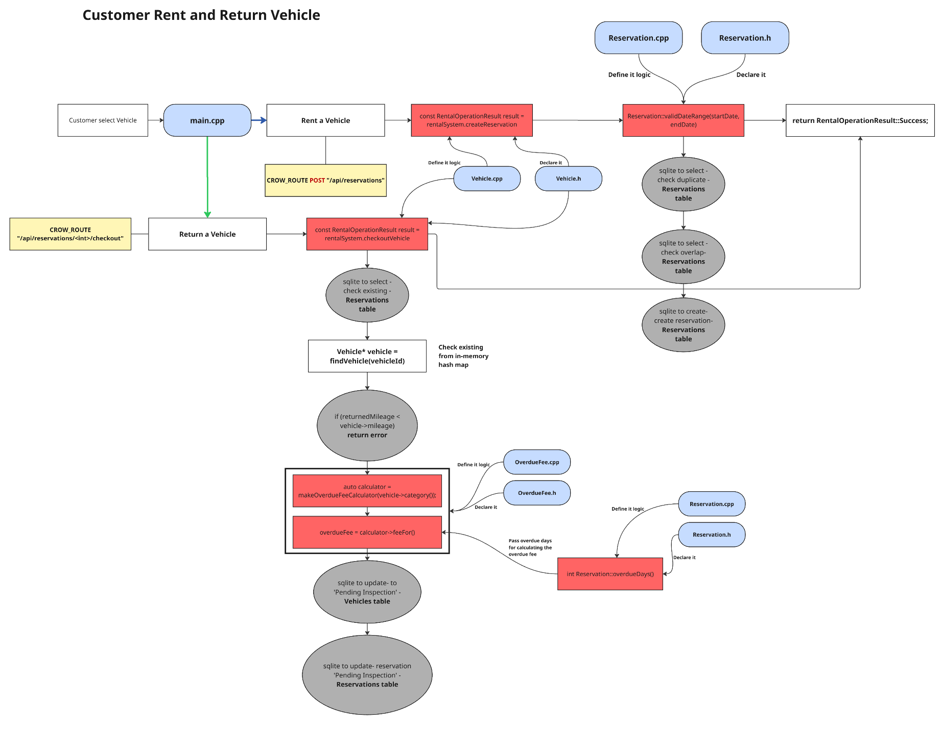
Figure 12 System Architecture - Customer Rent and Return Vehicle
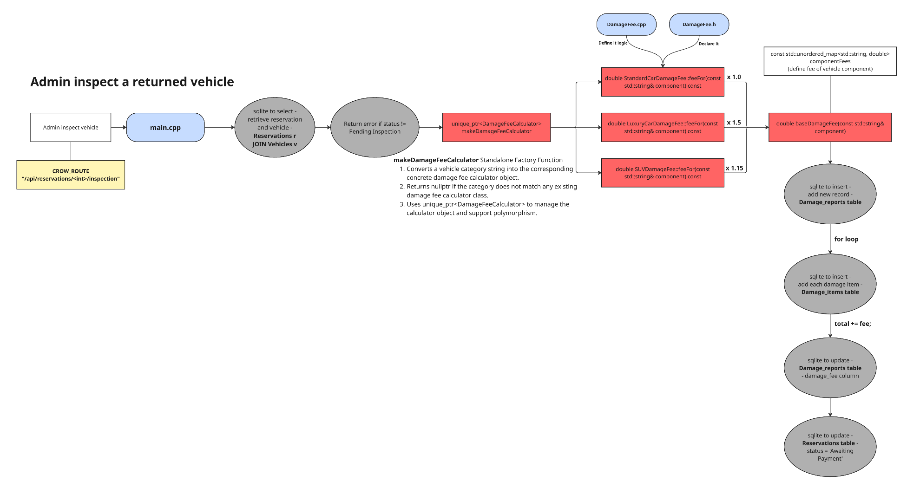
Figure 13 System Architecture - Admin Inspect a Returned Vehicle

13.0 Bonus Mark Alignment
Feature | Current Usage | Explain
unique_ptr | Vehicle ownership, authentication providers, fee calculators | Automatic Memory Management + Single Ownership + No Manual delete.
vector | Stores authentication providers | Organises and stores multiple providers.
unordered_map | Vehicle storage, sessions, damage-fee lookup | Stores key-value pairs.
Exception handling | SQLite, input conversion, and query errors use try/catch | Handling the error
ifstream | ifstream serves HTML, CSS, JS, and images | Read frontend files and send their contents to the browser.
Lambda expressions | Crow HTTP routes use lambdas | It means not necessary to specially create a function with a name, we can directly define and execute a set of functions.
Move semantics | std::move transfers strings and unique_ptr ownership | Transfer Ownership instead of Copying Data
const correctness | Many getters and calculation methods are const; const references are used | Protect data from unintended modification.
constexpr | Malaysia UTC offset is declared constexpr | Used to define a compile-time constant
Namespaces | Anonymous namespaces and SQLite namespace usage | Avoid naming conflicts and organise code more clearly

14.0 Limitation
The current system has the following limitations:
- Automatic check-in is not a background service: Reservation status updates occur during startup and selected API requests. If the application receives no requests, status changes do not occur immediately.
- Possible concurrent booking race condition: The system checks for overlapping reservations before inserting a new reservation. Without a database-level exclusion mechanism or stronger locking strategy, two simultaneous requests could potentially pass the check before either insert completes.
- Sessions are not persistent: Login sessions are stored in an in-memory unordered_map. Restarting the server logs out all users, and the system does not provide distributed session storage.
- Limited pricing flexibility: The system currently hardcodes long-term rental discounts and component damage fees, preventing administrators from configuring them through the interface.
- Limited operational features: The system does not appear to include automated email/SMS notifications, customer identity verification, digital contracts, document uploads, or vehicle availability calendars.
- Omission of luxury pricing breakdown during customer booking: When customers browse and attempt to rent luxury vehicles, the frontend booking modal displays only the base daily rate without explicitly showing the mandatory security deposit and daily insurance rate before final confirmation.

15.0 Future Improvements
To address the system's current limitations, future improvements will focus on enhancing scalability, reliability, and administrative flexibility. Reservation status synchronization can be upgraded to a dedicated asynchronous background service, while database transactions will help prevent concurrent booking conflicts. In-memory sessions can be replaced with database-backed session management to improve session persistence across restarts. Additionally, an administrative configuration interface will allow dynamic management of pricing rules and component damage fees. Other improvements include automated notifications, digital document uploads, customer identity verification, and interactive availability calendars. Finally, the booking interface can display an itemized pricing breakdown, including security deposits and daily insurance rates for luxury vehicles, before booking confirmation.

16.0 References
Team Coastr. (2025, May 28). Top 7 car rental business challenges & how to solve them. Coastr. https://www.coastr.com/post/expert-solutions-to-the-7-most-common-vehicle-rental-business-challenges
Visual Paradigm. (2019). What is use case diagram? Visual-Paradigm.Com. https://www.visual-paradigm.com/guide/uml-unified-modeling-language/what-is-use-case-diagram/
Visual Paradigm. (2024). UML class diagram tutorial. Visual-Paradigm.Com. https://www.visual-paradigm.com/guide/uml-unified-modeling-language/uml-class-diagram-tutorial/

